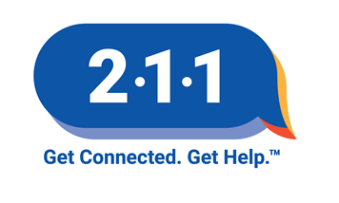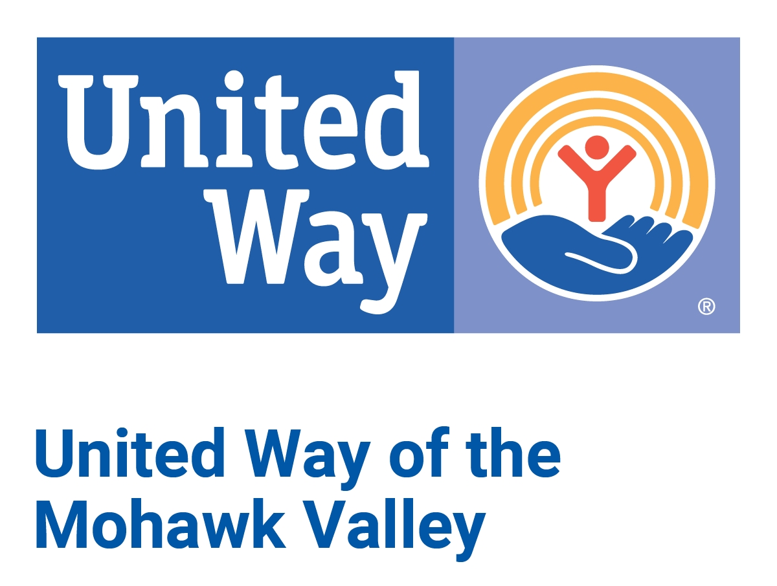

211 Mid-York
ORGANIZATION INFORMATION FORM
Thank you for helping to build 211 Mid-York’s Resource Database!

GENERAL ORGANIZATION INFORMATION:
1. ORGANIZATION Name:
2. AKAs (if any):
3. Address (street and/or mailing):
4. Is this the address where people access service? Yes No (if no please list it in question 20)
5. Primary phone number:

6. Additional phone numbers (Please note type of number after each ex: “Admin”, “TTY”, etc.):

7. Fax:
8. Web site:
9. Email:

10. CEO/Director Information:

- Name:
- Title:
- Phone Number:
- Email:

11. Description of Organization:
12. Does organization have services specifically designed to meet the need of individuals with intellectual or developmental disabilities? Yes No
13. IRS Status (please select most appropriate):

Government (please select type): ^{City} ^{Town} ^{County} ^{State} ^{Federal} ^{Special District}

Church Affiliated
Coalition/Other Group
For Profit
Private Non-Profit
Public Non-Profit
Individual/Group Practitioner

14. List the names of each program to be listed in 2-1-1 Mid-York as part of this organization:
15. Person completing this form:

- Name:
- Title:
- E-mail:
- Phone Number:

15a. Back-up contact for agency listing:

- Name:
- Title:
- E-mail:
- Phone Number:

SERVICE OR PROGRAM SPECIFIC INFORMATION: (Please complete Questions 16-29 for each program, copying page 2 as often as needed)

16. Name of Program or Service:
17. Director of Program or Service and contact information (if different than the CEO/Director on question 10):

- Name:
- Title:
- E-mail:
- Phone Number:

18. Program purpose/description of services:
19. Service specific phone number:
20. What address would people use for service (if different than the one listed on question 3)?
21. Coverage area served:

Anywhere
U.S., any state
NYS
Madison Co. (all)
Oneida Co. (all)
Herkimer Co (all)
Utica
Rome
City of Oneida
Little Falls
Zip code specific, please list:
School district specific, please list:
Other:

22. Eligibility Requirements:

- AGE, check all that apply:

ANY AGE
Prenatal
0-5
6-12
13-18
18-adulthood
65+
Other:

- Income Guidelines:
- Veteran Status:
- Other qualifying criteria:

23. Fees or costs (if any, note any sliding fee scale, payment method insurance accepted):

24. Application process (how should people contact you for service?), select all that apply:

By appointment Accept walk-ins Other

25. Documents required (what documents are required to receive the service), select all that apply:

None
Proof of expenses
Proof of address
Proof of income
Other

26. Hours (please list hours of service below):

24/7

Sunday:
Monday:
Tuesday:
Wednesday:
Thursday:
Friday:
Saturday:

27. If services can be accessed after hours, describe how:
28. Languages Spoken (other than English):
29. Accessibility issues to be aware of:

HOW TO SUBMIT THIS COMPLETED NEW ORGANIZATION LISTING FORM
- Save the completed form using your agency name and date to your computer.
- Email the completed form as an attachment to 211midyork@ABVI-Goodwill.com or fax to 585-327-5518.

LISTED ORGANIZATION RESPONSIBILITES
Updates are the lifeblood of a quality information and referral service. Our commitment to quality requires us to inactive or drop unresponsive organizations. If an organization does not respond to 211’s repeated requests by email, fax, letter, or phone to update their information in the database, we can’t confidently refer someone seeking assistance. 211 is pleased to receive updates as they occur throughout the year. We also accommodate seasonal services, such as a holiday meal service, only listing these when they are available.
At a minimum, all organizations listed in 211 must renew or verify their listings annually. Here are the steps to follow:
  - You will receive an e-mail with an attachment from 211midyork@ABVI-Goodwill.com
The e-mail attachment lists your organization’s contact information, along with program and site details.
  - Save the completed form using your agency name and date to your computer.
  - Review the document for accuracy and updates that are needed. You may edit, add to, or inactivate details.
  - Your verification is needed even if there are no changes.
  - Email the completed form to 211midyork@ABVI-Goodwill.com or fax to 585-327-5518.

Our database is updated every day as we learn about changes. 211 Mid-York staff continually checks resources and contacts to verify changes to ensure that our data is as accurate and up to date as possible. We encourage you to contact 211 Mid-York staff immediately if you see any information you believe is inaccurate.

ABOUT US:
211 Mid-York is a program of United Way of the Mohawk Valley, Inc. (UWMV). We staff 211 Mid-York locally with people responsible for community outreach, ensuring quality, providing regional knowledge, and our website 211midyork.org. 211 Mid-York’s contact center is housed at Goodwill of the Finger Lakes, Inc., where resource specialists use a data base specifically for our region.
Questions about your organization's listing or to send updates?
Goodwill of the Finger Lakes, Inc.
E-mail the Resource Team at: 211midyork@ABVI-Goodwill.com
or Fax: 585-327-5518

Need promotional material, want a presentation on 2-1-1, website questions or unhappy with your 2-1-1 experience? Contact:
UWVGUA

Kristen Synakowski
Financial Stability Initiatives Manager
KristenS@unitedwaymv.org
315-733-4691 x 229

Betty-Joan Beaudry
Director of Community Impact and 211
211midyork@unitedwaymv.org
315-733-4691 x 225

Thank you for listing with 211 Mid-York.

